 ­

© Hexaware Technologies Limited. All rights reserved.

www.hexaware.com

Internship Report

* Content Area Content Area Content Area Content Area Content Area Content Area Content Area
* Content Area Content Area Content Area Content Area Content Area Content Area Content Area
* Content Area Content Area Content Area Content Area Content Area Content Area Content Area
* Content Area Content Area Content Area Content Area Content Area Content Area Content Area
* Content Area Content Area Content Area Content Area Content Area Content Area Content Area

**Grow Digital >>**

**Shrink IT <<**

VERTICALS

**Internship**

**on**

**Video Analytics**

**By**

**Sruthi K V**

**Mentor & Guide**

**Ranganathan Rajkumar**

**For**

**Hexaware Technologies Limited**

**SIPCOT IT Park, Siruseri, Chennai**

**Internship**

**on**

**Video Analytics**

**Period:** 05-Dec-2017 to 16-Mar-2018

This report is submitted by **Sruthi K V** on 16th Mar 2018

|  |  |
| --- | --- |
| Under the Guidance of | |
| Ranganathan Rajkumar,  Project Director,  Business Intelligence and Analytics,  Hexaware Technologies Limited, Chennai. |  |
| A Soundarapandian,  Senior Manager,  Business Intelligence and Analytics,  Hexaware Technologies Limited, Chennai. |  |
| Kumaresan Natarajan,  Technical Architect,  Business Intelligence and Analytics,  Hexaware Technologies Limited, Chennai. |  |

Contents

1 EXECUTIVE SUMMARY 5

2 ABOUT VIDEO ANALYTICS 6

2.1.1 Steps involved in Facial Recognition: 6

2.1.2 Major Usecases of Video analytics: 6

2.1.3 Objective: 7

2.1.4 Description 7

3 REQUIREMENTS 8

3.1.1 Software prerequisites: 8

3.1.2 Python Package Installations: 8

4 AWS REKOGNITION VIDEO ANALYTICS AND DEEP LEARNING 9

4.1.1 Amazon Rekognition : 9

4.1.2 Benefits: 9

4.1.3 Deep Learning: 9

5 FACE DETECTION USING VIDEO ANALYTICS 10

5.1 Architecture: 10

6 CONCLUSION 16

EXECUTIVE SUMMARY

|  |  |  |
| --- | --- | --- |
| **ACTIVITY** | **LEARNING** | **ACHIEVEMENT** |
| **Requirements /**  **Project Use case:** | Learnt all the analytics related terms and definitions. | Understood the requirement of “Face Detection using Video analytics” |
| **Requirements Gathering & Sample Data Collection, Preprocessing** | Learnt about different dimensions of a technology | Gathered knowledge on learning about the initiatives to the project. |
| **Analytics Part** | To check if all the requirements gathered can actually work on the project | Analysis done based on the constraints of the project. |
| **Collection of video frames using Python** | Learnt to program with python for collecting the video frames using OpenCV3. | Ability to code with python for any scenario |
| **Amazon Web Services** | Learnt about the various AWS services offered | Understood the services in use according to the project. |
| **Creating AWS Collection - Machine learning** | Learnt on how to train a machine using collection | Gathered brief knowledge on what machine learning is and how it works. |
| **Twitter API Calls** | Learnt how API calls are done | Displaying twitter page using API calls. |
| **Output accuracy checking** | Learnt about testing an output against different constraints. | Had a knowledge on how to make an output work efficient. |
| **Documentation of the work done so far** | Learnt on gathering the necessary details of the project. | Understood the essential contents to present the project. |

ABOUT VIDEO ANALYTICS

**Video Analytics** (also **video content analytics**,) is the capability of automatically analysing video to detect and determine temporal and spatial events.

This technical capability is used in a wide range of domains including entertainment, health-care, retail, automotive, transport, home automation, flame and smoke detection, safety and security. The algorithms can be implemented as software on general purpose machines, or as hardware in specialized video processing units.

### Steps involved in Facial Recognition:

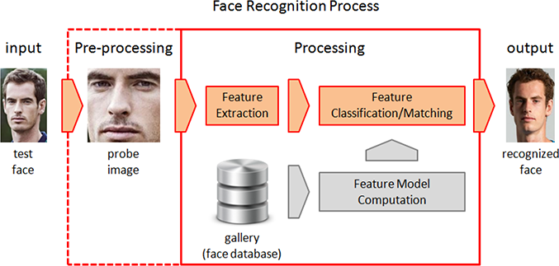

### Major Usecases of Video analytics:

### Object, scene, and activity detection

### Facial recognition

### Facial analysis

### Person tracking

### Unsafe content detection

### Objective:

To display a welcome message to the users along with their details by detecting, recognizing and analyzing their faces using Rekognition Service, an Artificial Intelligence provided by Amazon Web Service (AWS).

### Description

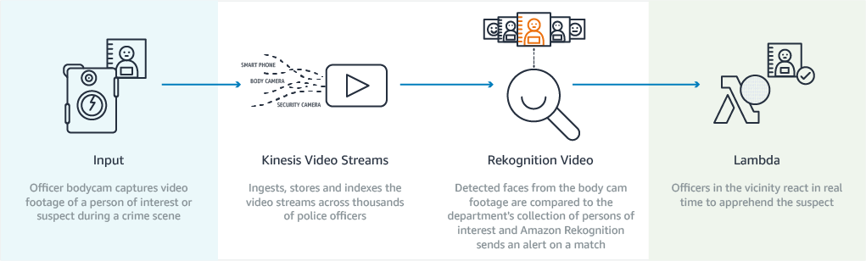

Video frames are captured by the IP CAMERA using openCV and sent to the AWS Kinesis stream as frames (JPEG/ PNG). The frames are then buffered for certain intervals and sent to the lambda function for any event to occur. The buffered video frames in Lambda are sent to the AWS Rekognition service for detecting and identifying faces in the frames by the deep learning algorithm. A welcome message is then displayed to the users followed by their name when the face recognition is successful.

Note: The user details (Face details and personal details) are to be fed and machine learned.

REQUIREMENTS

### Software prerequisites:

* Python 2.7+
* Microsoft Visual C++ 2015 Redistributable

### Python Package Installations:

* Install PIP
* Install Virtualenv
* Install [OpenCV](https://github.com/opencv/opencv) 3
* Install Boto3
* Install Pynt
* Install [pytz](http://pytz.sourceforge.net/)

AWS REKOGNITION VIDEO ANALYTICS AND DEEP LEARNING

### Amazon Rekognition:

Amazon Rekognition makes it easy to add image and video analysis to our applications. You just provide an image or video to the Rekognition API, and the service can identify the objects, people, text, scenes, and activities, as well as detect any inappropriate content. Amazon Rekognition also provides highly accurate facial analysis and facial recognition. You can detect, analyze, and compare faces for a wide variety of user verification, cataloging, people counting, and public safety use cases.

### Benefits:

### Easily integrate powerful image and video analysis into any app

### Continually learning

### Fully managed

### Batch and real-time analysis

### Low cost

### Deep Learning:

**Deep learning** (also known as **deep structured learning** or **hierarchical learning**) is part of a broader family of machine learning methods based on learning data representations, as opposed to task-specific algorithms. Learning can be supervised, semi-supervised or unsupervised.

The **Amazon Rekognition Image** service was created by using deep learning neural network models and was based on the same technology that enables Prime Photos to analyze billions of images each day. At the time of Rekognition’s release, its primary focus was providing scalable, automated analysis, search, and classification of images.  Well that all changes today as I am excited to tell you about some additional features the service now has to offer.

FACE DETECTION USING VIDEO ANALYTICS

### C:\Users\Karthick\Desktop\Hexaware Video Analyzer.jpgArchitecture:

### Steps Involved:

## The video is captured by IP camera using OpenCV client and passed into AWS Kinesis stream.

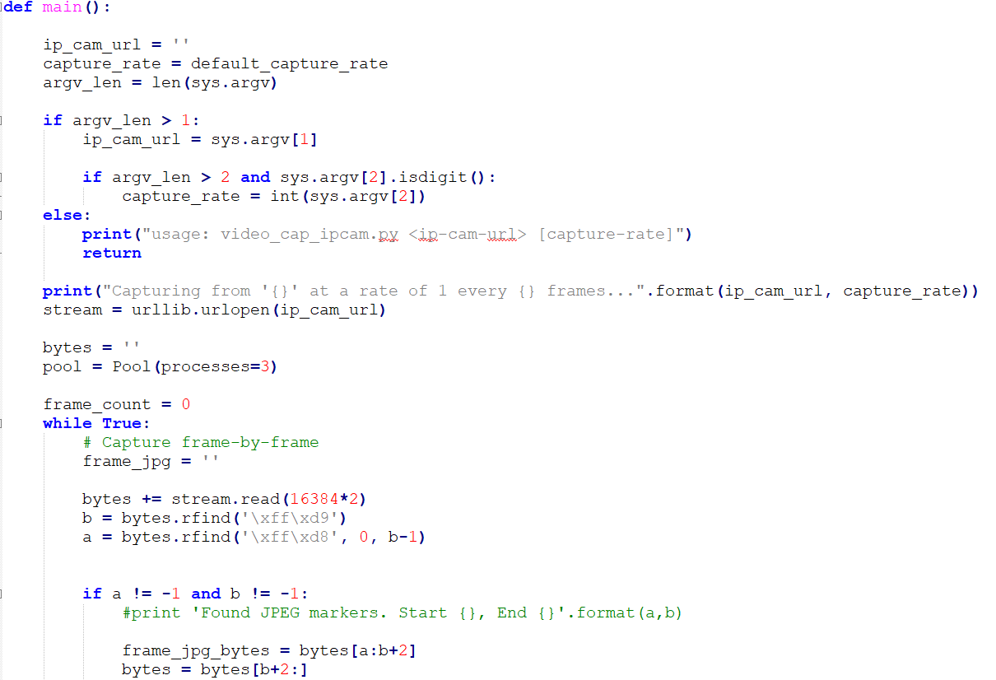

## 

## Video is buffered as frames in the form of JPEG/PNG and sent to the imageprocessor lambda function at regular interval of time.

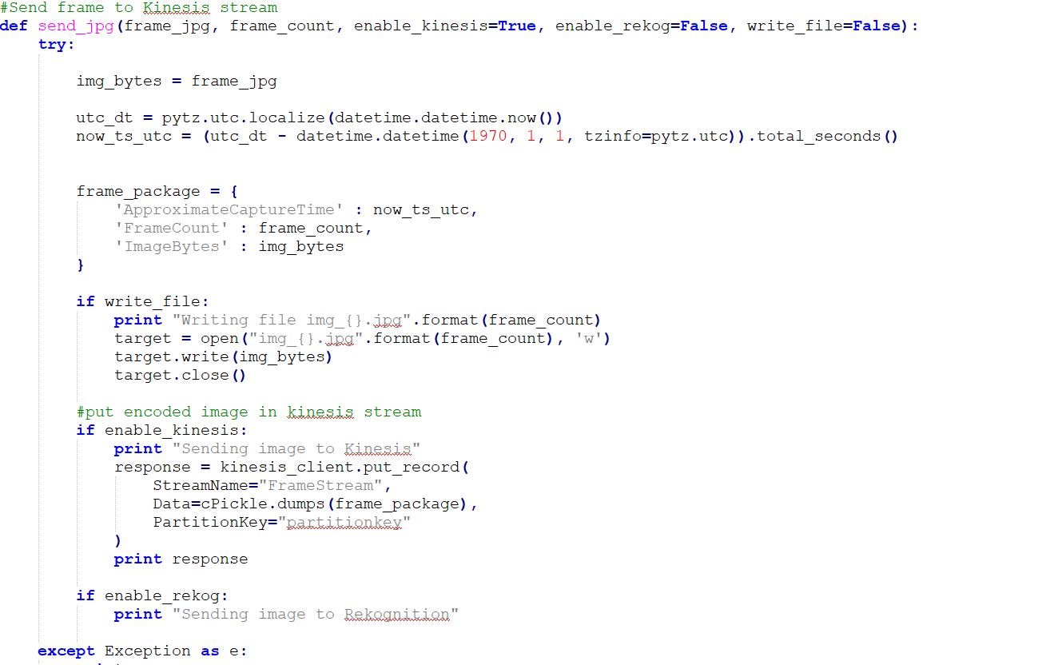

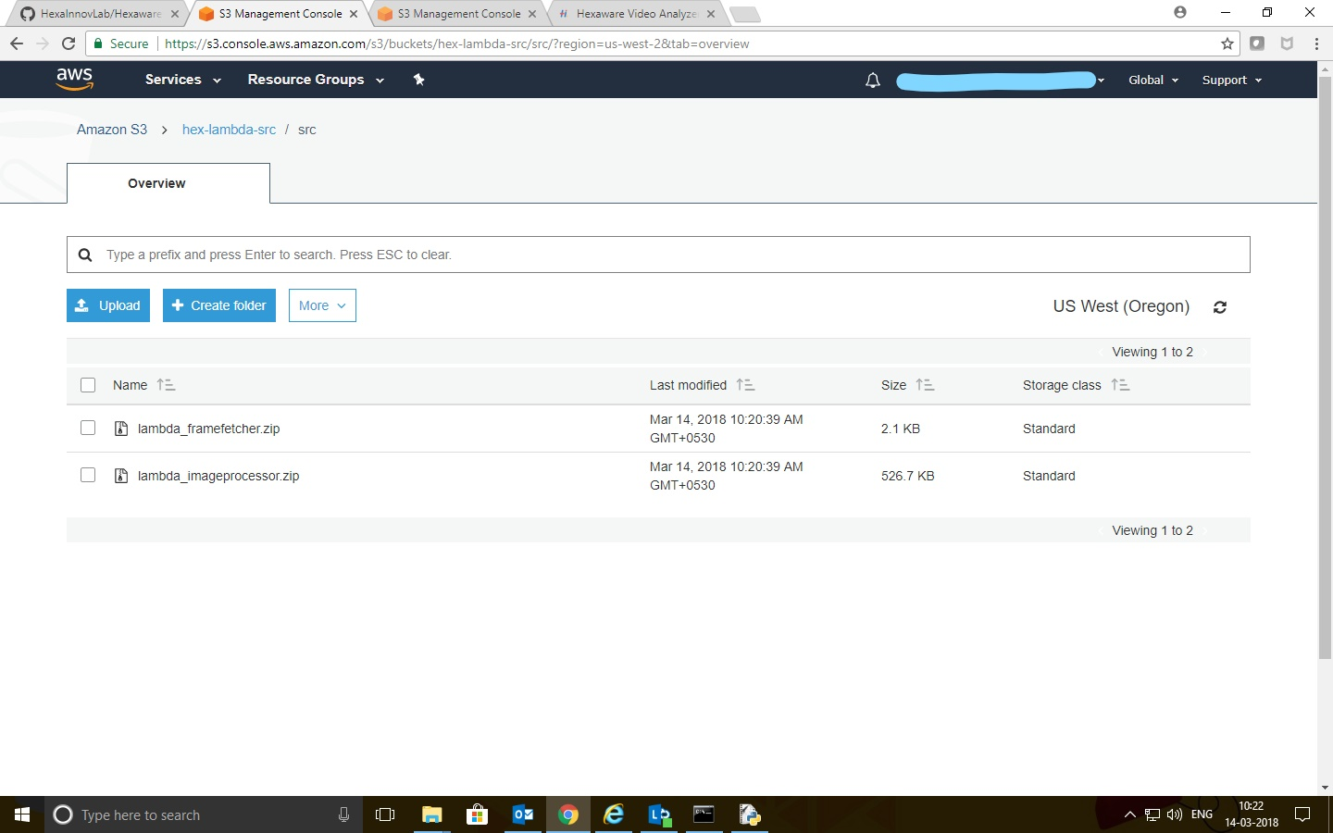

## The imageprocessor lambda function is invoked and frames are sent to the AWS Rekognition API, in response to the event occurred.

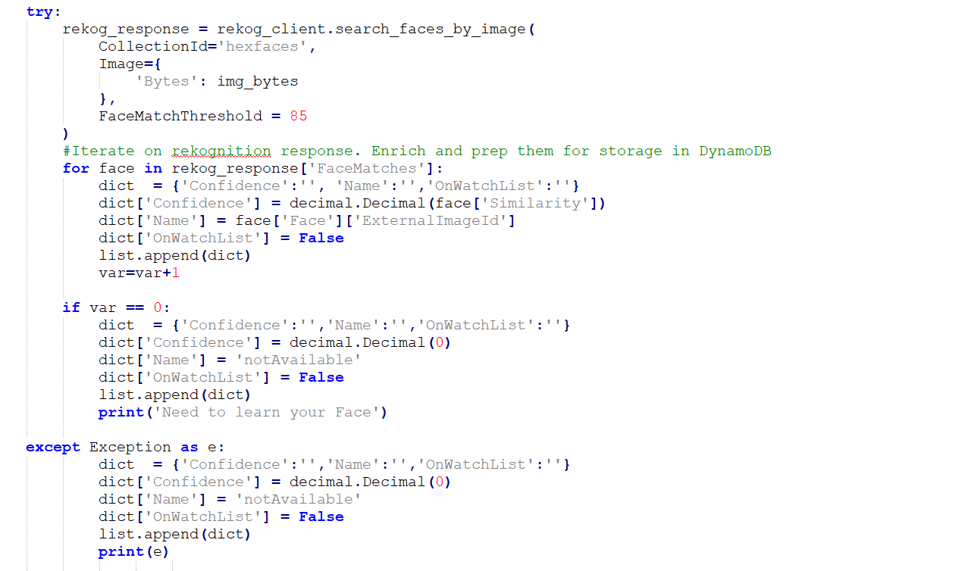

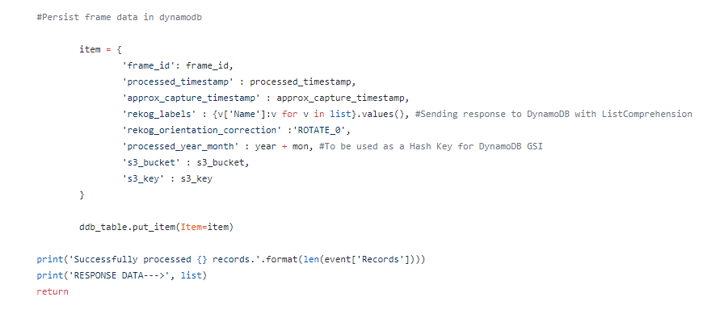

## 

## The frames are stored in AWS S3 Bucket

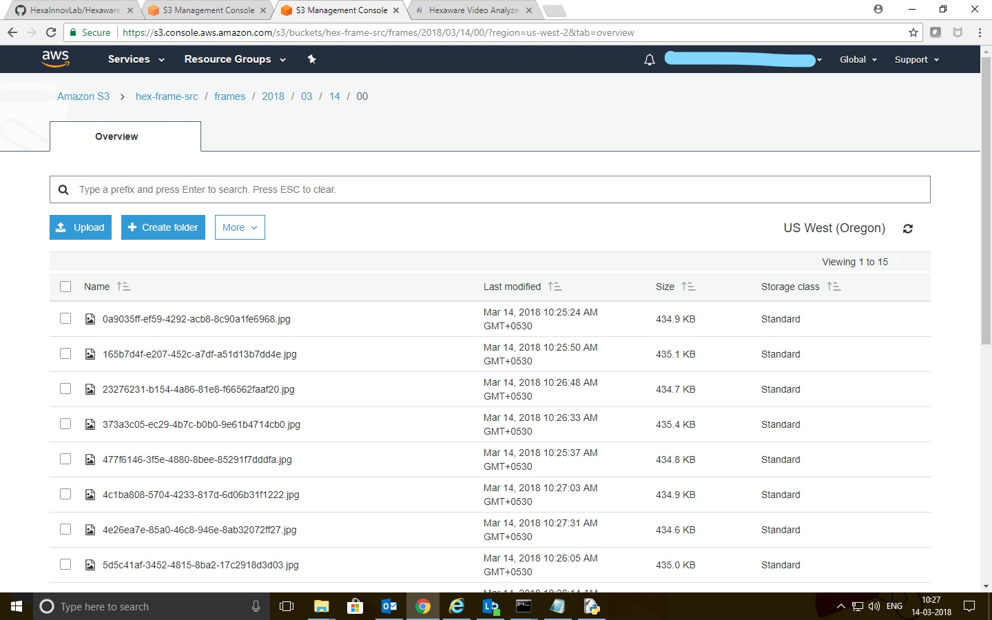

## The frames metadata (Detected faces) are stored in AWS DynamoDB

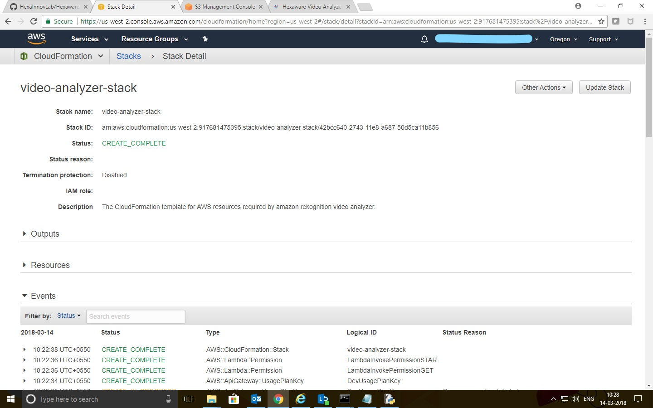

## 

## On the other side, the framefetcher lambda is invoked to fetch frames and metadata to display on Web UI using Amazon API Gateway

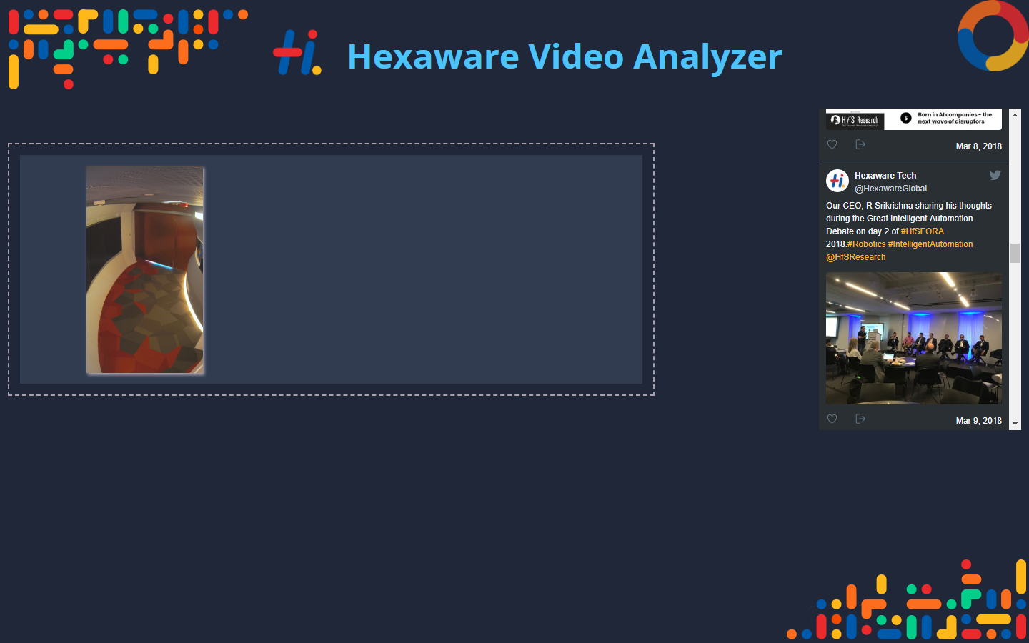

CONCLUSION

[[

|  |  |
| --- | --- |
| **OBJECTIVE** | To display a welcome message to the users along with their details by detecting, recognizing and analyzing their faces |
| **INPUT** | Live Video Stream |
| **EXPECTED OUTPUT** | Face Recognition and Welcome message of the users along with their name |
| **SERVICE** | AWS Rekognition |
| **MACHINE LEARNING** | Deep Learning |
| **ACHIEVEMENT** | The Face Recognition were found to be with 87.3% accuracy using AWS Rekognition service. |